**ASSIGNMENT – I**

Diksha Krishnan  
311519104015  
dikshakrish5@gmail.com

1. **PROGRAM:**

list = []

n = int(input("Enter the number of elements: "))

print("Enter the elements: ")

for i in range(0,n):

ele = int(input())

list.append(ele)

#Inserting at given position

print("\n")

pos = int(input("Enter the position to insert: "))

val = int(input("Enter the value to be inserted: "))

list.insert(pos-1,val)

#Printing the list

print("\n")

print("Modified List: ",list)

#Removing first occurrence of integer

print("\n")

list.remove(list[0])

print("Modified list after removal of first occurrence: ",list)

#Appending element

print("\n")

val1 = int(input("Enter the value to be appended: "))

list.append(val1)

print("Modified list: ",list)

#Sorting the list

print("\n")

list.sort()

print("Sorted list: ",list)

#Popping from a list

print("\n")

pos = int(input("Enter the position of the value to be popped: "))

removed_elem = list.pop(pos)

print("Removed element: ",removed_elem)

print("Updated list: ",list)

#Reversing the list

print("\n")

list.reverse()

print("Reversed list: ",list)

**OUTPUT:**

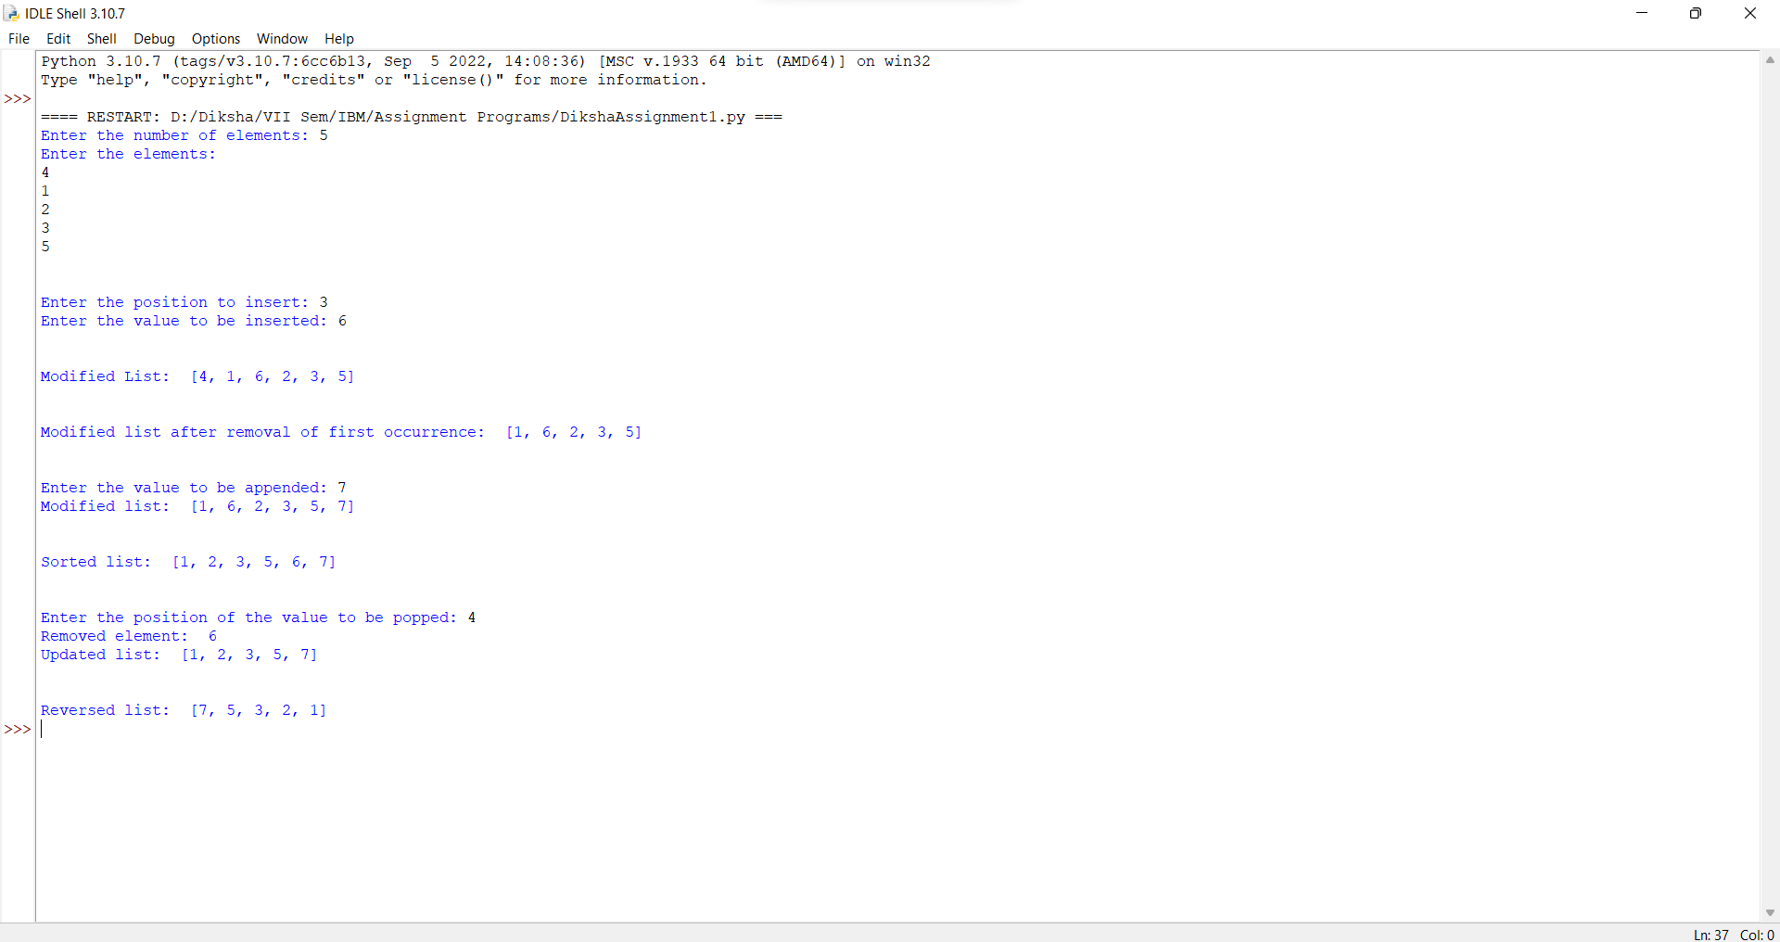

1. **PROGRAM:**

n1 = int(input("Enter the first value: "))

n2 = int(input("Enter the second value: "))

print("\n")

print("----------SIMPLE CALCULATOR----------")

print("Sum: ",n1+n2)

print("Difference: ",n1-n2)

d = float(n1/n2)

print("Quotient: ",d)

print("Remainder: ",n1%n2)

print("Exponentiation: ",n1**n2)

print("Floor Division: ",n1//n2)

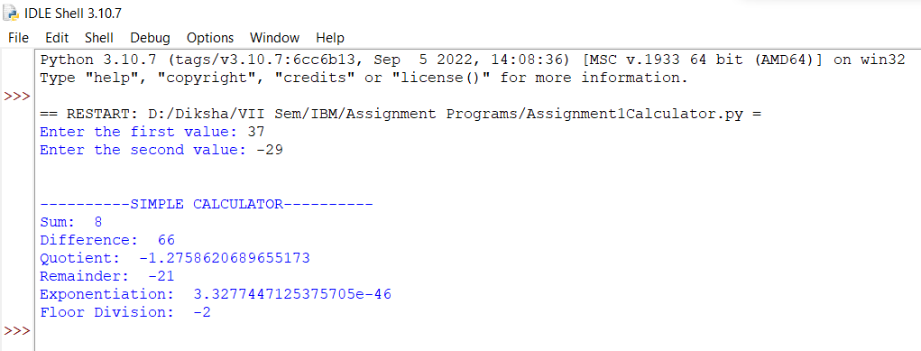**OUTPUT:**

1. **PROGRAM:**

str1 = input("Enter first string: ")

str2 = input("Enter second string: ")

str1 = str1+str2

print("\nConcatenated string: ",str1)

#Reverse using slicing

print("\nReversed string: ",str1[::-1])

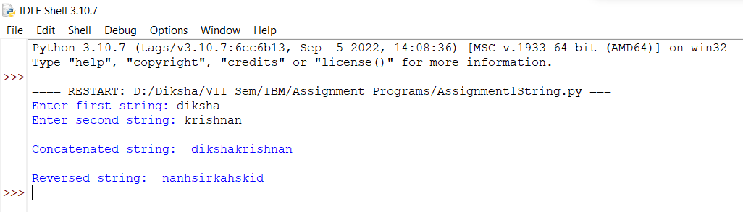**OUTPUT:**

1. Why is Python Programming language popular?

* It is simple to learn and use
* Useful for web development purposes
* Extensively used in Data Science
* Has multiple libraries and frameworks
* Flexibility and reliability

1. What are the other frameworks that can be used with Python?

* TurboGears
* Pyramid
* Django
* CherryPy

1. Full form of WSGI

A: Web Server Gateway Interface